Ross Paths

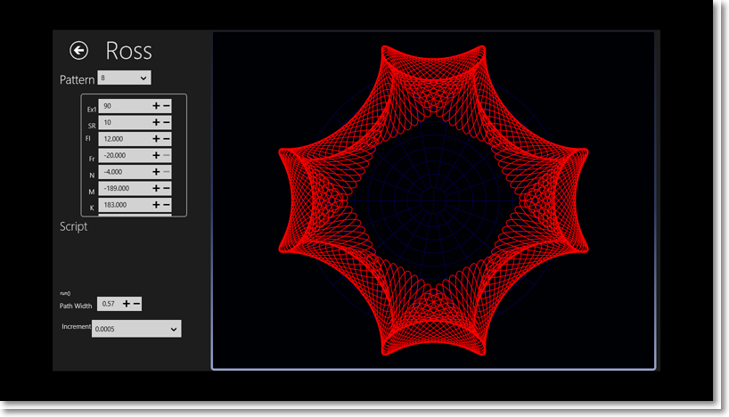
The page describing the Ross paths is similar to the Bazely page and has the same functionality. You can adjust the initial values and export them to file, then subsequently import them during another session. There are 38 Ross Patterns the image below is the last pre-defined pattern
